Crown 5000VZ Fault LEDs

Check on main board, you have some diagnostic leds (red ones), and tell which stays lighted after power it on.
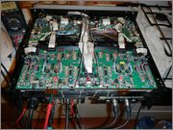
If DC/LF led stays on, you have Offset DC on output, possible one transistor from quadrant output be failed.
If Fault led stays on, you have shorted output

