The Gupta period Delhi Iron Pillar (see Figure 1) is testimony to the high level of skill achieved by the ancient Indian iron smiths in the extraction and processing of iron. This Pillar has attracted the attention of corrosion technologists because it has withstood corrosion for the last 1600 years. The presence of relatively high phosphorus (0.25 wt-%) in the forge welded Delhi Iron Pillar plays a major role in its excellent corrosion resistance [1, 2]. The presence of phosphorus leads to the formation of a protective passive film on the surface, which provides the Pillar its exceptional corrosion resistance properties. However, in modern steel making process, the phosphorus content is controlled to 0.05 wt. % because phosphorus segregation to grain boundaries reduces ductility of steel.

Figure 1: Delhi Iron Pillar at Qutub Minar complex in New Delhi.
How do we use the knowledge learnt from the study of the Iron Pillar for modern day technological applications? In order to provide answers to this question, a detailed study was undertaken by a PhD student, Gadadhar Sahoo, under the guidance of Professor R. Balasubramaniam of the Materials and Metallurgical Engineering Department to understand possible industrial applications of phosphoric irons. The first aim was to render the phosphoric irons ductile. The second aim was to locate a modern application wherein the corrosion resistance of phosphoric irons could be put to good use. We shall delve into these aspects in this story of the week.
Ductility is a very important property from the point of practical application of any engineering material. How do we make phosphoric irons ductile? It is known that phosphorus segregation to the grain boundaries makes these locations weak and results in poor ductility. Therefore, the first aim of the work was to find out methods to keep phosphorus away from the grain boundary. It was first realized that phosphorus will not be present in regions where carbon is located in the iron matrix because phosphorus is a substitutional solute element whereas carbon is an interstitial solute element. Therefore, a small amount of carbon needs to be maintained in phosphoric irons. The next challenge is to locate these carbon atoms along the grain boundaries, thereby keeping the phosphorus atoms away from these locations. In order to achieve this, an intelligent use of the phase transformations in the iron-phosphorus system was applied.
The phase diagram of iron-phosphorus shows a (alpha + gamma) dual phase region at high temperature (see Fig. 2). If a phosphoric iron in the composition range 0.25 and 0.50 wt %P, is soaked in the two phase region (temperature between 1000ºC and 1100ºC), then austenite phase (g) will precipitate on the grain boundaries of ferrite phase (a). This is well known in physical metallurgy. Austenite has a higher solubility for carbon than phosphorus and therefore all the carbon is pushed to the grain boundary region while the phosphorus is removed from the grain boundary region. After a suitable soaking time at high temperature, the phosphoric irons can be air cooled to room temperature. The beneficial aspect of this treatment is that phosphorus, which was removed from the grain boundary regions, does not go back to these regions during air cooling because phosphorus requires time to diffuse to the grain boundary regions. In this manner, a high temperature soaking in the two phase region and subsequent air cooling should result in good ductility for phosphoric irons.

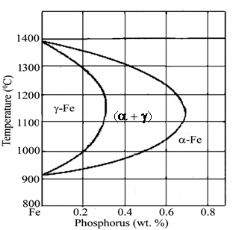
Figure 2: The high temperature gamma loop region of the Fe�P phase diagram.
In order to test this hypothesis, three phosphoric irons P1 (0.11 wt. % P), P2 (0.32 wt. % P) and P3 (0.49 wt. % P) were ingot cast and later forged to rods. In all these phosphoric irons, a small amount (0.02 wt. %) of carbon was maintained. Appropriate heat treatments were devised for these irons, as per the philosophy outlined above. Tensile testing of triplicate samples indicated good ducitlities for phosphoric irons, especially P1 and P2 (see Fig. 3). In the same figure, the tensile test result of a commercial reinforcement bar (TISCON of Tata Steel) used for concrete reinforcement applications is also shown.
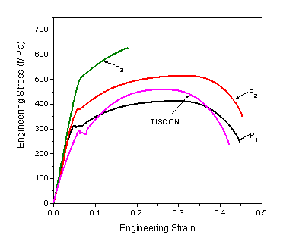
Figure 3: Typical engineering stress-strain curve of the specimens P1, P2, P3 and TISCON.
Good ductilities were obtained for phosphoric irons because phosphorus was kept away from the grain boundaries. This was confirmed by microscopy (see Fig. 4). In this figure, the optical micrograph of P2, that was soaked in the (alpha + gamma) dual phase region is shown, after etching with Nital. The light contrast at the grain boundaries indicates locations of low phosphorus content. Interestingly, this structure is known as a �ghost� structure because although the entire structure is ferrite at room temperature, the location of prior austenite and prior ferrite is revealed by the contrast that obtains due to differences in phosphorus contents. Well, this is not important anyway here, but the idea of �ghosts� does also apply in metallurgy!

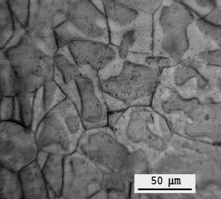
Figure 4: Optical micrograph of heat-treated specimen P2 after etching with Nital.
The good room temperature ductility obtained in phosphoric irons will remain as long as the materials are not exposed to the temperature range of 200ºC to 600ºC for long times. When phosphorus containing steels are exposed in this temperature range, phosphorus diffuses and segregates to the grain boundaries, leading to their embrittlement. This is known as temper embrittlement. In case phosphoric irons have to be applied commercially in ambient temperature conditions, there would be absolutely no problems regarding their ductility. We need to keep this in mind while looking for suitable applications where phosphoric irons can be applied.

In this context, it is important to consider the production of reinforcing bars in concrete because a large tonnage of steel produced in a developing country like India is used for reinforcement of concrete in structural applications. The reinforcement bars have to possess the necessary strength, ductility and corrosion resistance. Modern-day reinforcement bars are strengthened by three methods, namely, microalloying with costly elements like Nb, Ti, etc., cold twisting (which used to be popular earlier), and by controlled cooling in the bar mill plus cooling process. The last process is increasingly becoming popular in India and you must have noticed the advertisements for bars indicating that they are �TMT bars� which stands for �thermo-mechanically treated bars.� Phosphoric irons can be processed by a similar method utilizing the existing arrangements, with the major difference being the ingot soaking, bar quenching and further cooling arrangements have to be fine tuned to produce phosphoric iron with a tough surface and a strong interior. This can be achieved by suitable design criteria [3].
The corrosion behavior of phosphoric irons has been evaluated in a wide variety of environments [4]. It was concluded that phosphoric irons possess necessary corrosion resistance in near neutral and alkaline conditions. A typical industrial application for which phosphoric irons may be applied is for reinforcing concrete. Therefore, the corrosion resistance of phosphoric irons was evaluated extensively in simulated concrete environments and compared with commercially available material from Tata Steel, Jamshedpur . The results of the detailed study indicate the superior corrosion resistance of phosphoric irons in concrete conditions. For example, the corrosion rate of TISCON was much higher compared to phosphoric irons. Interestingly, phosphoric irons exhibited good passivity in concrete environments. A wide variety of techniques was used to study corrosion in concrete conditions [4]. These included polarization methods (linear and Tafel polarization), potentiodynamic polarization and potentiostatic polarization, electrochemical impedance spectroscopy, salt fog immersion, complete immersion and atmospheric immersion experiments. Apart from samples exposed to aqueous solutions, cement-grouted samples were also tested to simulate actual application conditions.
It is known that chloride ions are damaging to surfaces because they generally tend to destabilize the protective passive films on the surface. Surprisingly, phosphoric irons showed excellent corrosion resistance even in their presence. This significant result indicates that phosphoric irons will provide good service in environments where chloride ions are present, like in case of structures near seacoast. As India possesses a large coast line, there is wide scope for using phosphoric irons in reinforced concrete structures near coastal areas, which generally call for higher material quality. This is the reason that the major steel makers in India , SAIL and TATA STEEL, market another quality of reinforcement bars, which they call CRS indicating �corrosion resistant steel.� Generally, these steels contain a little amount of Cu and Cr as alloying additions and they are costly compared to normal reinforcement bars. Phosphoric irons can perform as good as, if not better, than these commercial CRS materials. An added advantage is that they will not be costly compared normal TMT bars.
In order to visually show the good corrosion behavior of phosphoric irons, the result of immersion testing in saturated Ca(OH)₂ solution containing 5 % NaCl is shown in Figure 5. The nature of surface after 125 days of immersion can be noted for three phosphoric irons and two commercial grades of reinforcement steels from Tata Steel (TISCON and CRS). The severe nature of corrosion in case of P1 , TISCON and CRS is quite clear. Phosphoric iron P3 is the most resistant, followed by P2 and then P1. These visual images clearly prove the beneficial effect of phosphorus in conferring corrosion resistance, especially in simulated concrete pore solution containing a relatively high concentration of aggressive chloride ions [5].
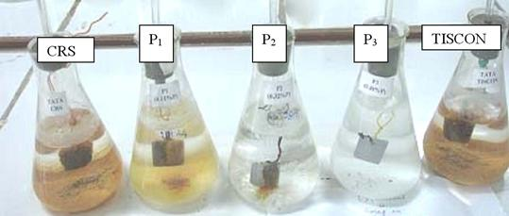
Figure 5: Immersion testing samples after 125 days of immersion in saturated Ca(OH)₂ solution containing 5 % NaCl.
We realize that ideas for developing phosphoric irons originated from the study of the Metallurgical Wonder of India � the Delhi Iron Pillar. You will all now, we hope, believe in the old adage that �the best of the new is often the long forgotten past.�
References:
    - R. Balasubramaniam, �On the Corrosion Resistance of the Delhi Iron Pillar,� Corrosion Science , 42 (2000) 2103-2129.
    - R. Balasubramaniam and A.V. Ramesh Kumar , � Characterization of Delhi Iron Pillar Rust by X-ray Diffraction, Fourier Infrared Spectroscopy and Mössbauer Spectroscopy,� Corrosion Science , 42 (2000) 2085-2101.
    - R. Balasubramaniam, � Phosphoric Irons for Concrete Reinforcement Applications,� Current Science , 85 (2003) 9.
    - Gadadhar Sahoo, �Corrosion of Novel Phosphoric Irons for Concrete Reinforcement Applications,� PhD. Thesis, IIT Kanpur, 2006, submitted.
    - R. Balasubramaniam and Gadadhar Sahoo, Corrosion Resistant Phosphoric Iron for Concrete Embedment and Reinforcements Application , Indian Patent Application Number 1823/Del/2005.

